The UFW Firewall

The default firewall configuration tool for Ubuntu is ufw which provides a user friendly way to

create an IPv4 or IPv6 host-based firewall.
1. First, ufw needs to be enabled. From a terminal prompt enter:

sudo ufw enable
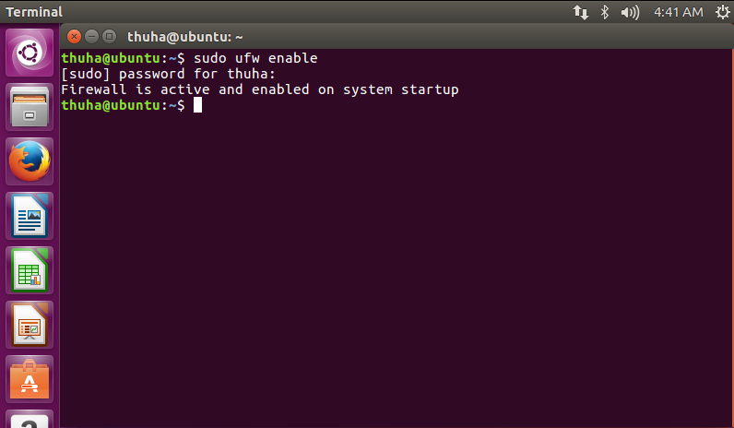

2. To open a port (ssh in this example):

sudo ufw allow 22

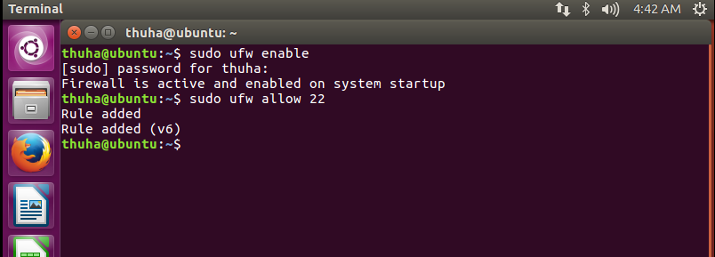
3. Similarly, to close an opened port:

sudo ufw deny 22

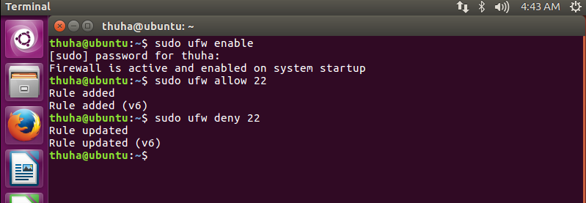
4. To remove a rule, use delete followed by the rule:

sudo ufw delete deny 22
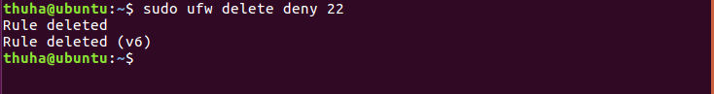
If you wanted to delete all the rules you can type:
sudo ufw reset

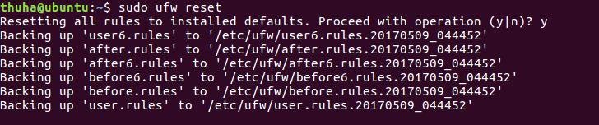

5. It is also possible to allow access from specific hosts or networks to a port. The following

command allows 10.28.108.37 to any ip address on this host:

sudo ufw allow proto tcp from 10.28.108.37 to any port
22

6. Replace 10.28.108.37 with 10.0.0.0/8 to allow ssh access from the entire subnet

7. ufw can be disabled by with the following command
ufw disable

8. One of the easiest methods for configuring the firewall is to deny all incoming and allow

all outgoing and then allow the ports you want to have open. Type

sudo ufw default deny incoming

sudo ufw default allow outgoing
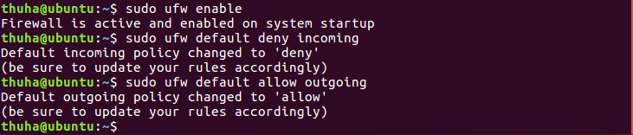

9. If the port you want to open or close is defined in /etc/services, you can use the port name

instead of the number. In the above examples, replace 22 with ssh.

Câu lệnh trả về rằng nó đã tồn tại, vì ở bước trên 6 ta đã dùng số port thay cho tên port

10. Type the following commands open ports for named services that I use: namely, SSH

(port 22), a web server (port 80). Any services named in /etc/services may be identified

by name instead of port number.

sudo ufw allow ssh

sudo ufw allow www

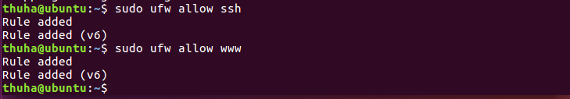
11. UFW also has a list of application presets, for common servers such as Apache,

OpenSSH, Lighttpd, and Samba. You can view the list by issuing the command:

sudo app list

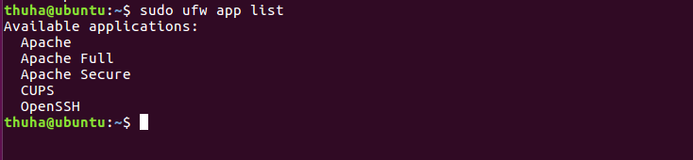

12. To open ports type (note the colon to denote port ranges)

sudo ufw allow 9091
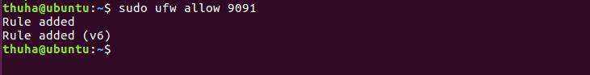
sudo ufw allow 20500:20599/tcp

sudo ufw allow 20500:20599/udp
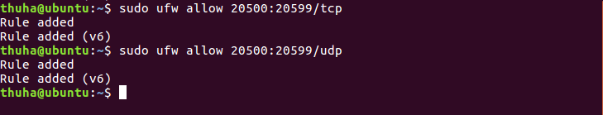
13. Check your configuration using

sudo ufw status verbose
